Department of Computing
Course Code: CS332
Class: BSCS
Lab 02: Client Server Communication
CLO4: Develop Distributed Applications/Systems

Date: January 29, 2026

Instructors: Dr. Shah Khalid

Submitted By:
Abrar Butt --- 460297 --- C

Lab 02: Client Server Communication
Introduction
This lab focuses on the concepts of client server communication.
Objectives
To understand the concepts and implement client server communication..
Tools/Software Requirement
MS Visual Studio 2013
Description
By using simple network applications, we can send files or messages over the internet. A socket is an object that symbolize a low-level connection point to the IP stack. This socket can be opened or closed or one of a set amount of intermediate states. A socket can deliver and receive data down this connection. Files is generally sent in blocks of a few kilobytes at a time for effectiveness; each of these blocks is named as a packet. Here are the list of well-known port numbers which usually used.
- Port 20, FTP Data
- Port 21, FTP Control
- Port 25, SMTP (email and outgoing)
- Port 53, DNS
- Port 80, HTTP (Web)
In this lab, we will explore the client server programming model in C#, however you are free to choose any language for the lab task.

Consider Simple Client and SERVER programs in C#
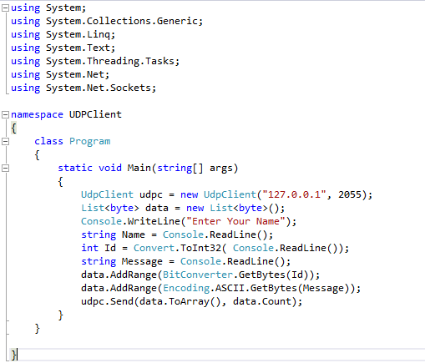
Figure 1: CLIENT CODE

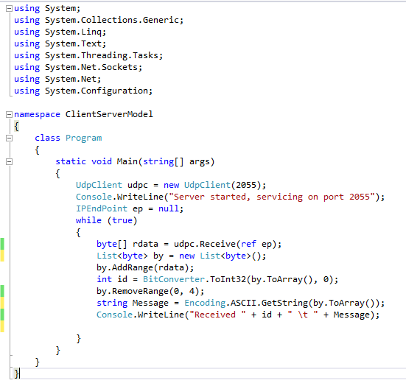
Figure 2: SERVER CODE

Lab Tasks
- Your task is to use the above mentioned program and convert it to group chat using event publish/subscribe architecture as discussed in class. Write a middleware that act as a chat group. Users can join and leave that group. Middleware broadcast the received messages to all the connected users.
Code:
This is chat server code..
import java.io.*;
import java.net.*;
import java.util.*;

class ClientHandler extends Thread {
private Socket socket;
private BufferedReader in;
private PrintWriter out;
private String userId;
private static Map<String, PrintWriter> clients = new HashMap<>();

public ClientHandler(Socket socket) {
this.socket = socket;
}

public void run() {
try {
in = new BufferedReader(new InputStreamReader(socket.getInputStream()));
out = new PrintWriter(socket.getOutputStream(), true);

out.println("Enter User ID:");
userId = in.readLine();
clients.put(userId, out);

broadcast("User " + userId + " joined the chat");

String message;
while ((message = in.readLine()) != null) {
if (message.startsWith("@")) {
String[] parts = message.split(" ", 2);
sendUnicast(parts[0].substring(1), parts[1]);
} else {
broadcast(userId + ": " + message);
}
}
} catch (Exception e) {
e.printStackTrace();
} finally {
clients.remove(userId);
broadcast("User " + userId + " left the chat");
}
}

private void broadcast(String msg) {
for (PrintWriter writer : clients.values()) {
writer.println(msg);
}
}

private void sendUnicast(String user, String msg) {
PrintWriter writer = clients.get(user);
if (writer != null) {
writer.println("(Private) " + userId + ": " + msg);
} else {
out.println("User not found.");
}
}
}

public class ChatServer {
public static void main(String[] args) throws Exception {
ServerSocket serverSocket = new ServerSocket(5000);
System.out.println("Chat Server Started on port 5000");

while (true) {
Socket socket = serverSocket.accept();
new ClientHandler(socket).start();
}
}
}

This is chatclient code..
import java.io.*;
import java.net.*;

public class ChatClient {
public static void main(String[] args) throws Exception {
Socket socket = new Socket("localhost", 5000);

BufferedReader in = new BufferedReader(
new InputStreamReader(socket.getInputStream()));
PrintWriter out = new PrintWriter(
socket.getOutputStream(), true);

BufferedReader keyboard = new BufferedReader(
new InputStreamReader(System.in));

new Thread(() -> {
try {
String msg;
while ((msg = in.readLine()) != null) {
System.out.println(msg);
}
} catch (Exception e) {
e.printStackTrace();
}
}).start();

String input;
while ((input = keyboard.readLine()) != null) {
out.println(input);
}
}
}

Output:

Two users
1.abrar
2.Zarnish
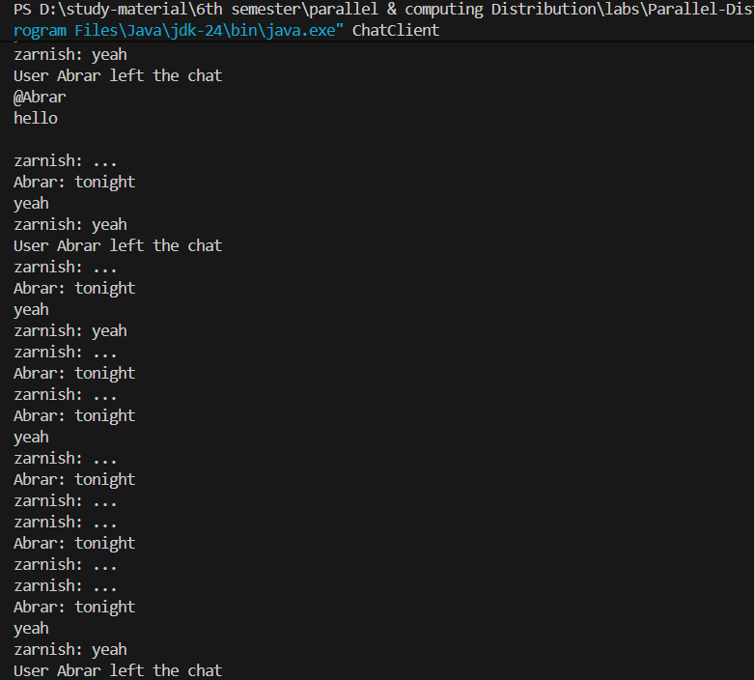
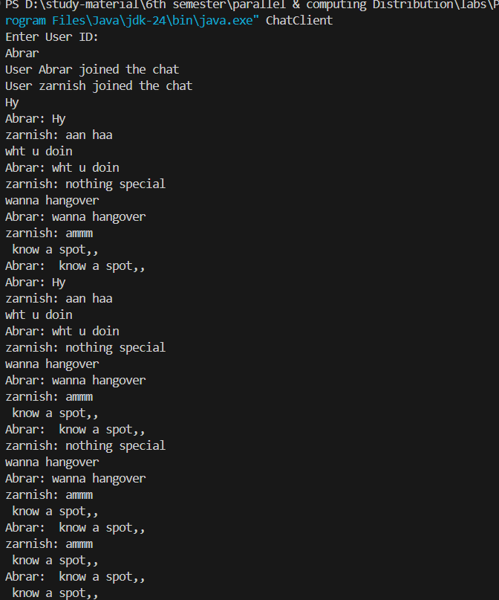

- Add another feature in this middleware which is based on unicast i.e. message send to particular user will not be received by all other users in the group. For this you can assume the user ID of all users is well-known or middleware can provide you that. Moreover, all the communication must be go through the middleware.

Code:
this is chatserver ..
import java.io.*;
import java.net.*;
import java.util.*;

class ClientHandler extends Thread {
private Socket socket;
private BufferedReader in;
private PrintWriter out;
private String userId;

// Thread-safe map of clients
private static Map<String, PrintWriter> clients = Collections.synchronizedMap(new HashMap<>());

public ClientHandler(Socket socket) {
this.socket = socket;
}

public void run() {
try {
in = new BufferedReader(new InputStreamReader(socket.getInputStream()));
out = new PrintWriter(socket.getOutputStream(), true);

// Ask for user ID
out.println("Enter User ID:");
userId = in.readLine().trim(); // removes extra spaces
clients.put(userId, out);

// Check for duplicate user ID
if (clients.containsKey(userId)) {
out.println("User ID already taken. Connection closed.");
socket.close();
return;
}

clients.put(userId, out);
broadcast("User " + userId + " joined the chat");

String message;
while ((message = in.readLine()) != null) {
if (message.startsWith("@")) {
// Private message
String[] parts = message.split(" ", 2);
if (parts.length >= 2) {
sendUnicast(parts[0].substring(1), parts[1]);
} else {
out.println("Invalid private message format. Use: @userId message");
}
} else {
// Broadcast to all
broadcast(userId + ": " + message);
}
}
} catch (IOException e) {
System.out.println("Connection error with user " + userId);
} finally {
try {
if (userId != null) {
clients.remove(userId);
broadcast("User " + userId + " left the chat");
}
if (socket != null)
socket.close();
} catch (IOException e) {
e.printStackTrace();
}
}
}

// Broadcast to all clients
private void broadcast(String msg) {
synchronized (clients) {
for (PrintWriter writer : clients.values()) {
writer.println(msg);
}
}
}

// Send message to a specific user only
private void sendUnicast(String recipient, String msg) {
PrintWriter writer = clients.get(recipient);
if (writer != null) {
writer.println("(Private) " + userId + ": " + msg);
out.println("(Private to " + recipient + "): " + msg); // optional echo to sender
} else {
out.println("User '" + recipient + "' not found.");
}
}
}

public class ChatServer {
public static void main(String[] args) throws IOException {
ServerSocket serverSocket = new ServerSocket(5000);
System.out.println("Chat Server Started on port 5000");

while (true) {
Socket socket = serverSocket.accept();
new ClientHandler(socket).start();
}
}
}

This is chat client..
import java.io.*;
import java.net.*;

public class ChatClient {
public static void main(String[] args) throws Exception {
Socket socket = new Socket("localhost", 5000);

BufferedReader in = new BufferedReader(
new InputStreamReader(socket.getInputStream()));
PrintWriter out = new PrintWriter(socket.getOutputStream(), true);

BufferedReader keyboard = new BufferedReader(
new InputStreamReader(System.in));

// Thread to listen for messages from server
new Thread(() -> {
try {
String msg;
while ((msg = in.readLine()) != null) {
System.out.println(msg);
}
} catch (IOException e) {
System.out.println("Disconnected from server.");
}
}).start();

// Thread to send messages to server
String input;
while ((input = keyboard.readLine()) != null) {
out.println(input);
}
}
}

Output:
Server is running so
client outputs:
1.Abrar
2.Ahmad
3.Talha
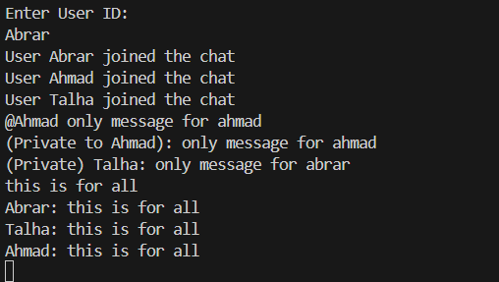
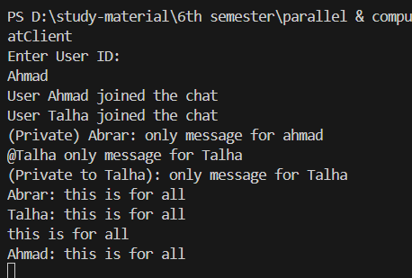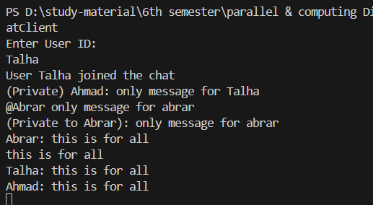
Code link github.com: https://github.com/Abrarbut/parallel-and-computing-distribution.git
Deliverables
Upload the project code files on LMS.

